Netspective Medigy Product Development Plan

Contents

Overview of Netspective Medigy Innovation Network 4

Medigy Unique Value Proposition Ideas 5

Medigy Marketplace Ideas 5

Medigy Marketplace Design Questions 5

Certification vs. Evaluation vs. Peer Review Notes 5

How to identify Medigy 6

Peer Review and Evaluation Methodologies Supported 6

Offering Types Supported 7

Medigy Teams 7

Infrastructure Teams 7

Content Teams 9

Innovation Lifecycle Management (ILM) and Vendor Management System (VMS) 11

Elaboration of Innovation Diffusion, for further study 12

Elaboration of ILM, for further study 12

Elaboration of Innovation Body of Knowledge (InnBoK) 13

Peer Review Capabilities 13

Content Addressable Dimensional Data (CADD) 14

CADDs for Offerings (Products, Services, Solutions, etc.) 14

“Earn Cash for Evaluating” 18

Community and Topic Homepage and CADDs [OP #2090] 18

Community Section Theme 19

Each Community is a Git Repo 19

Individuals and Influencers Home Page and CADDs [OP #2234] 19

Lectio-like Medigy extension for submissions and alerts [OP #2091] 20

Top-level Q&A similar to Roadmap.com and StackOverflow, etc. [OP #2458] 20

CB Insights Market Maps as new category source, categories, and offerings (communities) [OP #2235] 20

External badges for inbound links (improves SEO) [OP #2092] 21

PostgreSQL Distributed Data Computing Platform (Pg**DCP**) – “Zero Middleware” for Structured Content 22

PgDCP schema objects migration and management strategy 22

PgDCP Extract, Transform, and Load strategy (ETL) strategy 22

PgDCP identity and row-level data access management strategy 22

PgDCP design strategy 22

PgDCP GraphQL API and external access strategy 23

Markdown Pipelines Infrastructure for Unstructured Content 23

Medigy Daily Brief Home Page Design 24

Daily Brief Submenu Items 24

Innovation Coach Home Page Design [OP #1100] 25

Knowledge taxonomies, equivalence, similarities, representation, and governance 25

Taxonomy for Medical Subject Headings (MeSH) 27

Taxonomy for Medical Device Offerings 27

Taxonomy from third-party recommendation platforms 27

Taxonomy for Medical Research Outcomes 27

A Taxonomy of Definitions for the Health Data Ecosystem 27

Enhancing our Marketplace through proper audience selection 27

Used by 28

Purchased by 28

Benefits 28

[Unblock Health] Enhancing our Marketplace by identifying the kind of data an offering collects, manages, etc. 28

[Unblock Health] Patient complaints about hospital services: applying a complaint taxonomy to analyse and respond to complaints 29

A TAXONOMY OF INNOVATION: CONFIGURATIONS OF ATTRIBUTES IN HEALTHCARE INNOVATIONS 30

A Taxonomy of Pervasive Healthcare Systems 30

A Taxonomy of Telemedicine Efforts with respect to Applications, Infrastructure, Delivery Tools, Type of Setting and Purpose (2005) 30

A Taxonomy of Integration Interventions Between Health Care and Public Health 30

# Overview of Netspective Medigy Innovation Network

Netspective *Medigy* is an innovation network and marketplace published at [www.medigy.com](http://www.medigy.com). Medigy starts with categorized suppliers/vendors/innovators on the supply side and hospitals, health systems, and independent practices on the buyer side. We have additional buyers like payers and patients but those aren’t our direct targets (we’ll indirectly benefit them). Other network participants include Analysts, Influencers, and Clinicians as well Regulators.

The central thesis for the Medigy Innovation Network is captured in the Modern Healthcare Article “[Peer networks drive software decisions by hospital CIOs](https://www.modernhealthcare.com/technology/peer-networks-drive-software-decisions-hospital-cios)”. Some notable pull quotes include:

* “Despite vendors spending untold marketing dollars pitching their products’ standing on rankings produced by Black Book Research, KLAS Research and others, CIOs seem to be more driven by what’s happening in the market and good-old-fashioned peer networking.”
* “Given the multimillion—if not multibillion—dollar stakes, it makes sense IT leaders would turn to the experiences of their peers.”
* “Lisa Grisim, associate CIO at Palo Alto, Calif.-based Stanford Children’s Health, also highlighted the perspective she gains from the CIO community—with an electronic twist. IT leaders at Stanford Children’s have moved many of these conversations online, by participating in group email lists with their colleagues. One of the electronic mailing lists Grisim is most active in is dedicated to CIOs at pediatric hospitals, which is coordinated through the Children’s Hospital Association.“
* “Grisim said Stanford Children’s uses the annual “Best in KLAS” rankings as part of its decisionmaking process, either before developing a request for proposals or after receiving responses, as a quick quality check.”
* “Many hospital leaders, such as Grisim, said they review KLAS’ reports for access to the firm’s research—the free-form responses providers give to the firm’s survey questions, which KLAS includes at the end of its reports—in addition to the rankings.”

Some quick notes about our current thinking:

* What economic advantage are we giving to one or both sides? None in our case since they’re not buying on our platform? [asked in this [Video](https://www.youtube.com/watch?v=4v_DLwmPMME)]
* Is there asymmetric in the supply and demand? Is there a white-hot center? [asked in this [Video](https://www.youtube.com/watch?v=4v_DLwmPMME)]
* How do you manage strategic uncertainty in buying decisions for complex multi-stakeholder multi-institutional medical technology? To me, this is less a certification problem and more of a multi-stakeholder decision making problem.
* Medigy is formally a decision network, basically an interactive evaluation framework, for complex healthcare solutions.
* Innovators self-attest to what they do but a peer network decides what's real and what works.
* Medigy's decision network can be a companion to Gartner, KLAS, Chilmark, and others. Reviews, scoring and judging is driven transparently by the community of buyers, influencers, and innovators using a structured peer review decision network.
* The best members of the network, those that are the most transparent about their quality attributes, can help force the opaque members over time and pull the entire marketplace up in from a quantitative evaluation perspective. Complex ecosystems cannot be evaluated without a peer reviewed and compositional decision network.

## Medigy Unique Value Proposition Ideas

These are some UVPs we can consider … needs more research.

* UVP #1: Show solutions that are interoperable
* UVP #2: Show solutions that might work together (enhance value)
* UVP #3: We can create community driven marketplaces
* UVP: Can we be an on-demand market or solution research platform like “[Native](https://www.youtube.com/watch?v=R5RILEwdQ4A)”? “*Quantitative Market Intelligence Collaboration Platform*”?

## Medigy Marketplace Ideas

Learn about marketplaces by reading these introductory materials.

* [Managing the Complexity of a Multi Layered B2B Marketplace](https://www.youtube.com/watch?v=fjHeyRwAZgY)
  + Are we like freight? We want digital health buying to become frictionless, but now it’s confusing and complicated like Ruthie said.
* Are we a Managed Marketplace? <https://www.youtube.com/watch?v=4bL1BogUxVE&t=21s>
* [The Next Crop of Billion Dollar Companies Will Be FinTech Enabled Marketplaces - Pete Flint, NFX](https://www.youtube.com/watch?v=a0nagJHt3NA)
* [What seed investors are looking for in marketplaces - Ockenfels, Kurek, Hoffer, Rico](https://www.youtube.com/watch?v=QWnnf6cxhKA)
* [NFX Marketplaces Scorecard 28 Elements of a Great Marketplace](https://www.youtube.com/watch?v=rJsyJdVgc8U&t=394s)
* [Community driven marketplaces - Julia Wadehn, Sam Huber, Eugen Russ](https://www.youtube.com/watch?v=VXutji8Uf74)
* [Successfully building a SaaS-enabled marketplace -Hanno Lippitsch, Stefan Batory, Julia Morrongiello](https://www.youtube.com/watch?v=SaA7uaFMxS0)
* [Best Practices in Decentralizing Decisions and Operations During Geographic Expansion](https://www.youtube.com/watch?v=lJ0ZZmxT2KM)
* [The Hidden Patterns of Great Startup Ideas](https://www.nfx.com/post/hidden-patterns-great-startup-ideas?utm_source=twitter&utm_campaign=nfxpost)

## Medigy Marketplace Design Questions

Watch “[Marketplace design questions](https://www.youtube.com/watch?v=4v_DLwmPMME)” on YouTube. Here are our draft answers:

* How frequently will participants visit (daily?)
* What’s our average selling price (our ASP is zero?)
* Can we own the payment flow? (no?)
* Do we have high fragmentation (yes!)

## Certification vs. Evaluation vs. Peer Review Notes

* Certification involves
  + Evaluation/Assessment
  + Assurances – Safety, security … self-attestation, influencer input
  + Arguments
  + Evidences – quantitative, structured; qualitative, structured; no comments without structure
* Automation
  + One or multiplicity of steps in certification
    - Evidence collection, argument validation
    - Reviews, Audits
  + Use of Tools
    - Algorithms, Implementations
    - Checklists?
* Trustworthiness – peer reviewed, community driven
* Questions to answer
  + What do you mean by Certification?
  + Which steps of certification that you consider for automation?
  + What is being certified?
  + What is the role of standards in certifications
  + Can certification be automated?
  + What is the role of formal methods in the certification tools?
  + What makes a tool trustworthy?
  + What are the artefacts required for making the tool(s) trustworthy?

## How to identify Medigy

* Medigy Innovation Council – the governance body
  + Medigy Physician Advisory Council
  + Medigy Nursing Advisory Council
  + Medigy Patient Advisory Council
  + Medigy Health System CIO Advisory Council
* Medigy Innovation Network – the marketplace
* Medigy Innovation Evaluation and Collaboration Platform – the technology
* Medigy Innovation Diffusion Services – professional services to help implement innovations
* Medigy Radio – podcasts about innovation diffusion and marketplace
* Medigy TV – videos and podcasts about innovation diffusion and marketplace

## Peer Review and Evaluation Methodologies Supported

* Profile completion and scoring – the “existence proof” of a product (is it “discoverable”?)
* Social reactions and ratings (e.g. star, “like”) – the “social proof” of a product
* Reputation authenticators (links to GitHub, Product Hunt, and other third-party references)
* Qualitative experiences (e.g. pros/cons, aggregated images, videos, etc. integrations, decisions, alternatives, etc.)
  + *Anecdotal evidence* (integrations “seen” by users, etc.) – perhaps all qualitative experience is just anecdotal evidence?
* Quantitative evaluations (LHC forms); when grouped and averaged, it becomes real evidence?
* Profile aggregations (personal, influencer, institutional)

## Offering Types Supported

* Product
* Service
* Solution
* Infrastructure

# Medigy Teams

Where possible, all feature teams should be aggressively independent and be able to prioritize and manage their work without impacting other teams. When properly defined, feature teams can make progress independently and then a small integration team pulls their work together.

## Infrastructure Teams

|  |  |  |  |  |  |
| --- | --- | --- | --- | --- | --- |
| Priority | Name | Target Customer | RACI Assignment | OP Project | Description |
| 0 | Content Markdown and Search Pipelines Infrastructure for Unstructured Content (1...n containers, 1..n git repos) |  | **Ratheesh KR**  Pittosh Poulose, Vinod G, Ditty Bijil, Jijo MP | [OP-Link](https://openproject.netspective.com/projects/markdown-pipelines-infrastructure-for-unstructured-content/work_packages) | Container-based pipelines that read from source and create git-managed markdown for use by publishers (preparing the data). Generate [permalinks](https://gohugo.io/content-management/urls/#permalink-configuration-values) and [aliases](https://gohugo.io/content-management/urls/#example-aliases) as part of markdown to allow medigy.com/go/* redirects and permalinks. Create Dropmark to MD, [Wordpress to MD](https://www.npmjs.com/package/wordpress-export-to-markdown), TT-RSS to MD, etc. |
| 0 | Hugo Publishing Infrastructure Container (1 container, 1 website) |  | **Jijo MP**  Shanil S, Vinod G, Rejina KP | [OP-Link](https://openproject.netspective.com/projects/hugo-publishing-infrastructure/work_packages) | Pulls markdown from the various pipelines and generates HTML for final publication. If done properly, nothing is generated as part of the publishing, it’s just pulling together all the unstructured content pipelines. Must know Hugo very well and track releases weekly (look on UpWork for Hugo experts that can act as reviewers). |
| 0 | Search Services Publishing Infrastructure Container (1 container, 1 ES instance) |  |  |  | Clones all content repos, and rebuilds complete ES instance for all pipeline containers each time. It may run every 30 minutes, as a follow up to the hugo publisher. |
| 1 | Content Addressable Dimensional Data (CADD) Infrastructure |  | **Jijo MP**  Alan Francis, Divya TS | [OP-Link](https://openproject.netspective.com/projects/content-addressable-dimensional-data-cadd-infrastructure/work_packages) | Prometheus metrics for any piece of content in the system or external permalink – social reactions, social interactions, and qualitative experience. |
| 1 | Full-text and Faceted Search Infrastructure |  | **Dhanya Sreejith**  Sarin CM | [OP-Link](https://openproject.netspective.com/projects/full-text-and-faceted-search-infrastructure/work_packages) | Generate [Algolia](https://forestry.io/blog/search-with-algolia-in-hugo/) (see [this component](https://github.com/replicatedhq/hugo-algolia) and [these instructions](https://forestry.io/blog/search-with-algolia-in-hugo/)) or ElasticSearch or other search pages at the same time publishing is done so that we can have full faceted search capabilities. [See other options](https://gohugo.io/tools/search/) on Hugo site. |
| 1 | Innovation Lifecycle Management (ILM) | BWH | **Ratheesh KR**  Ditty Bijil, Surya SR, Geo VL, Jijo MP, Ajay K | [OP-Link](https://openproject.netspective.com/projects/innovation-lifecycle-management-ilm/work_packages) | OpenProject-based vendor procurement and innovation education, research, evaluation, intake, piloting, operationalization, implementation, and dissemination capabilities. Medigy UX will push content into OpenProject ILM and then customers will use OP for ILM functionality. We may build React-Admin UX on top for easier management in the future (2020). |
| 1 | MeSH-based topic classification and knowledge management governance |  | **Abdul Razak**  Ajmal MA, Divya TS, Mohammad Sufyan, Ajay K | [OP-Link](https://openproject.netspective.com/projects/mesh-based-topic-classification-and-knowledge-management-governance/work_packages) | “Categories” will be known as “Topics” and need hierarchical classification tied to NIH Medical Subject Headings (MeSH) as the “bridge” across taxonomies. |
| 1 | Netspective Attest | Redox | **Geo VL**  Alan Francis, Jeeba Joy V, Joshy Jose | [OP-Link](https://openproject.netspective.com/projects/netspective-attest/work_packages?query_id=44) | Legacy Attest based on custom project management, LHC Forms, Git |
| 1 | PostgreSQL Distributed Data Computing Platform (Pg**DCP**) for Structured Content |  | **Ratheesh KR**  Ditty Bijil, Surya SR, Shanil Sasikumar, Abdul Razak | [OP-Link](https://openproject.netspective.com/projects/postgresql-distributed-data-computing-platform-pgdcp-for-structured-content/work_packages) | Container-based Pipelinewise and Singer.io pipelines that read from source and create PostgreSQL PgDCP views from which Markdown Pipelines Infrastructure for Unstructured Content create publishing-ready content. |
| 1 | Terminology Services Infrastructure |  | **Abdul Razak**  Ajmal MA |  | Protégé and Git for OWL-based revision-controlled authoring with [Apache Jena](https://jena.apache.org/) and LHC Forms autocomplete API |
| 1 | Trust, Authenticity and Authority Management |  | **Mary JJ**  Dhanya Seejith, Stephy TL, Hazeef, Moideen, Rejina KP |  | SEO |
| 2 | Content Addressable Quantitative Evaluation (CAQE) Infrastructure |  | **Geo VL**  Alan Francis |  | LHC Forms based schema and structured data capture for quantitative evaluations of any piece of content in the system or external permalink |
| 2 | Identity and Access Management (IAM) |  | **Raphael VP** |  | [Keycloak](https://www.keycloak.org/) identity system which allows all aggregated professional profiles (NPI, influencers, etc.) to become users in the system with identity brokering (e.g. Twitter, LinkedIn, GitHub, etc.) |
| 2 | Professional Profile Aggregation from Regulated Sources | GrandRounds | **Raphael VP**  Geo VL |  | Individuals (professionals) and institutions need to be stored in [Keycloak](https://www.keycloak.org/) and OpenLDAP and allow *progressive profiling* (see below). The identity is managed in Keycloak now (2019) but progressive profiling is done in SuiteCRM or other CRMs later (2020). |
| 2 | Subscriptions, offering follows, e-mail newsletters and daily briefings |  | **Geo VL**  Alan Francis |  | Allow all addressable content summary areas to be followed (e.g. offerings, news, events, opinion, etc.). Then, send Daily Brief emails which will help us build our newsletter audience to increase interaction and reads. |
| 2 | Utilization Analytics |  | **Mahesh Prabhu**  Prathitha CB |  | Feedback and usage telemetry |
| 3 | IMAP Façades and Outlook Actionable Messages (OAM) |  | **Shahid Shah**  Robert |  | Allow OpenProject content to be viewed and managed through IMAP and OAM so that Outlook and other e-mail clients can be a first-class citizens from a UX perspective. |
| 3 | Netspective Attest NG |  | **Geo VL**  Alan Francis |  | Next-generation Attest based on OpenProject, LHC Forms, Git |
| 3 | Progressive Profiling for Professionals | GrandRounds | **Raphael VP**  Geo VL |  | Continuation of the *Professional Profile Aggregation from Regulated Sources* capability. see [this](https://www.kunocreative.com/blog/progressive-profiling) and [this](https://www.smartbugmedia.com/blog/what-is-progressive-profiling-and-how-does-it-work) post for explanation of progressive profiling. |
| 3 | Terminology Services Infrastructure NG |  | **Abdul Razak**  Ajmal MA |  | Next-generation [Distributed Terminology System (DTS)](http://www.apelondts.org/AboutDTS/tabid/130/Default.aspx) or [Snow Owl®](https://docs.b2i.sg/snow-owl/) open source terminology servers with revision-control capabilities and collaborative authoring platform. |
| 3 | Innovation Jobs on Demand |  |  |  | Like other job boards, especially [Nomad Health](https://nomadhealth.com/). Since we’ll have influencers, physicians, and others with NPIs we can offer full job matching capabilities using detailed skills, knowledge of specific products (e.g. offerings, services, etc. from our innovation network). |
| 4 | Live Structured Datasets and APIs |  | **TBD** |  | Provide PgDCP or CKAN access to “live datasets” (anything that we should offer as APIs instead of HTML pages) |

## Content Teams

|  |  |  |  |
| --- | --- | --- | --- |
| Priority | Name | RACI Assignment | Description |
| 0 | Netspective Medigy Feeds Curation Team (FC) | **Radhika** | Find all digital health, medical device, healthcare IT related feeds and include them in both bundles and by recency. RSS Feeds that do not have any articles updated since January 1, 2017 should be placed in the “Archived” tab in TT RSS. Also, use [RSS Feed Aggregators like Feedspot](https://blog.feedspot.com/healthcare_rss_feeds/) to curate new feeds from there (use their categories to map into our Topics) |
| 0 | Netspective Medigy Healthcare Cybersecurity and Third Party Risk Management (Opsfolio) Team | **Mary, Mahesh, and others** | The entire Opsfolio.com site should become one of the first Topic-centered communities. We can have a Content Markdown Pipeline container created that will just [convert from WordPress](https://www.npmjs.com/package/wordpress-export-to-markdown) to a Medigy Community – the same can be used for any future WordPress site. |
| 0 | Netspective Medigy Innovation Diffusion, ILM, and D&I Science Team (ILM) | **Anna Schoenbach, Radhika, and Shahid** | Create original and curated content around Netspective Medigy Innovation Lifecycle Management (ILM), innovation diffusion, and innovation dissemination & implementation research |
| 0 | Netspective Medigy News Curation Team (NC) | **Radhika** | Continuation of brief.health and news.healthcareguys.com work. |
| 0 | Netspective Medigy Topic Classification Governance, Equivalencies, and Taxonomies Team (KRG) | **Mohammad Sufyan with Radhika as SME** | Manage all work associated with topic classification, similarities, and equivalencies so that “related” content is easier and SEO is improved |
| 1 | Netspective Medigy Events Communities and Exhibitor Catalog Expansion Team (ECECE) | **Aitia with Radhika assisting as SME** | The Medigy Events Communities and Exhibitor Catalog Expansion Team finds healthcare IT, digital health, etc. events and curates them to help generate SEO. For specific events, they go into the event site and begin curating offerings from those events’ exhibitors and sponsors. The following is in priority order:   * Starting with HIMSS 2019 conference and those vendors – create HIMSS 2019 categories in OWL and scrape, copy/paste all vendors on the HIMSS 2019 site to expand the Medigy offerings catalog. * Do the same for HLTH 2019 and Diabetes Technology Society meeting * Do the same for Arab Health 2020 * Do the same for HIMSS 2020 |
| 1 | Netspective Medigy Events Communities News, Announcements, PR, and Related Content Team (ECN) | **Aitia** | Find all news, recognitions, announcements, etc. related to the events (e.g. HIMSS19, HLTH19, Arab Health 2020, HIMSS 2020, etc.) and curate them so they show in the specific event community. We want to promote events so that event organizers use us to manage their vendor catalogs, exhibitors, etc. lists. |
| 1 | Netspective Medigy Innovation Body of Knowledge (BoK) tied to NODE Health and others | **Mohammad Sufyan with Shahid and Radhika as SMEs** | Learn from and use the [Patient Experience BoK](https://www.theberylinstitute.org/page/PXKNOWLEDGE), [HIM BoK](https://bok.ahima.org/), [SWEBoK](https://www.computer.org/education/bodies-of-knowledge/software-engineering), [Project Management Body of Knowledge](https://en.wikipedia.org/wiki/Project_Management_Body_of_Knowledge) (PMBoK), [IT Security BoK](https://csrc.nist.gov/glossary/term/IT-Security-Body-of-Knowledge-Topics-and-Concepts), and [BABoK](https://en.wikipedia.org/wiki/A_Guide_to_the_Business_Analysis_Body_of_Knowledge).tied to [NIH Medical Subject Headings](https://www.nlm.nih.gov/mesh/meshhome.html) (MeSH) terminology. Find similar BoKs. |
| 1 | Netspective Medigy Offerings Catalog Quality and Profile Completeness Team (CQPC) | **Aitia** | Starts going through recently added (whenever they get added) Medigy offerings’ catalogs and sees where they can correct mistakes and add as much to each offering’s profile as possible. Their OKR is profile completeness plus profile quality and we should measure them against it. |
| 2 | Netspective “Medigy Pro” content available only by subscription – some for hospitals, others for innovators | **TBD** | Actionable content like Quality Management System (QMS) and other ILM (hospital) and SDLC (innovators) advice. |
| 2 | Netspective Medigy Offerings Catalog Expansion Team (CEX) | **Aitia** | Continuous discovery of offerings from any source beyond events like above. This would start with Interoperability Proving Ground (IPG) but also include other marketplace and product listing sites. |
| 2 | Netspective Medigy Speaker’s Bureau | **Aitia** | Curate speakers from various speakers bureaus and by allowing influencers to use CADDs to indicate their interest in speaking. Learn more from [CHIME Speakers Bureau](https://chimecentral.org/chime-technologies/chime-speakers-bureau/) and others. |

# Innovation Lifecycle Management (ILM) and Vendor Management System (VMS)

Our hospital clients need the ability to manage their innovators and vendors through a disciplined process. Our focus will be more on ILM vs. VMS but we need to consider the complete workflows. VMSs help enterprises with end-to-end vendor management from initial contact to finalizing a deal or establishing a business relationship. All innovators are seeking to become a vendor within a hospital, health system, physician practice, and other healthcare delivery organization (HDOs). Thus, an ILM and VMS in HDOs is inextricably linked.

* **Master list of HDOs using CMS Hospital Compare**. The nation’s list of hospitals is maintained by [CMS Hospital Compare](https://data.medicare.gov/) so we should create PgDCP based database of all the [hospitals CSV](https://data.medicare.gov/) entries [using this approach](https://info.crunchydata.com/blog/fast-csv-and-json-ingestion-in-postgresql-with-copy) and create SQL views for the Markdown Pipelines we need to create.
* **Vendor search, discovery and follow / subscribe**.
  + Ability to search, filter, and find offerings that match criteria against the data we have in the database.
  + Ability to “subscribe” to the filter / search criteria and find what matches new items.
* **Vendor screening**. Retrieve and verify supplier data like business reports, financial and credit risk data. Use the AMA’s Digital Health Implementation Playbook Step 4: Evaluating the Vendor as a guide.
* **Vendor Shortlisting – multiple shortlists are “Projects”, but projects can have different “natures” (campaign, initiative, etc.) when created. Thus, all content can be placed into projects and tracked by individual (private project) or teams (business projects by invite) or publicly (which might just become a Community).**
  + Ability to create a project and define its nature – perhaps as a CADD or an Attest Campaign.
  + Ability to place offerings into a project. This can be done using CADD or either Attest or OpenProject.
  + Ability to invite people to the project and let them review items in the project.
  + Ability to allow people to add qualitative and quantitative evaluations on the items in the project and invite others to do evaluations.
  + Ability to see insights for numbers, have a project dashboard to show what's being evaluated, etc.
  + Ability to create custom communities for publicizing the shortlisted items (a public project is basically a “Community”)
* **Vendor onboarding**. Vendors can be onboarded by allowing innovators to create their own records or hospitals can create them and then let vendors claim their accounts.
* **Vendor capability scoring**. This is all our current Medigy CADDs for social reactions, social interactions, qualitative experience, and quantitative evaluations. Hospitals can invite vendors to fill out their own experiences and profiles and then hire Netspective or other influencers to get other customers to fill out evaluations as usual.
* **Vendor self-service**. Instead of the hospital having to enter data for all the vendors, vendors can be invited to manage everything themselves.
* **Integration with AMA’s Physician Innovation Network and AHA’s Innovation Network**. The American Medical Association’s [Physician Innovation Network](https://innovationmatch.ama-assn.org/) should be integrated along with AHA’s network.
* **Vendor risk scoring**. [See McKinsey post](https://www.mckinsey.com/business-functions/risk/our-insights/cyber-risk-measurement-and-the-holistic-cybersecurity-approach) about how to create comprehensive cybersecurity score – instead of just cybersecurity scoring, though we’ll expand to full vendor risk scoring for business risk, financial risk, etc.
* **Vendor interactions and corrective actions**. With sub-par supplier performance, initiate corrective action plans (SCAR) or offboard them.
* **Definitive Health style data with ability for HDOs to suggest explanations and improvements of their scores.** In CMS Hospital Compare there is no ability for hospital data or scores to be commented upon by hospitals. If their data is incorrect, hospitals have no recourse. In Medigy, we’ll let them suggest explanations and work with them to improve their scores in the future.
* **HDO strategic plans and initiatives sharing**. Once the markdown files are created for each HDO using the approach above, allow CADD style Prometheus metrics for different kinds of data like HDO strategic plans, HDO initiatives, social reactions, social interactions, qualitative experience, quantitative evaluations, and file uploads of various kinds of items.
* **Buyer intention sharing plus open and private RFPs publications**. The HDO home page can also allow CADDs to be create that allow hospitals to say “I want to buy…” (e.g. their wishlists) and upload public or private RFPs so that vendors can see them.

## Elaboration of Innovation Diffusion, for further study

* [Malcolm Gladwell on Bridging the Gap Between Innovation and Adoption](https://www.pcmag.com/article/371748/malcolm-gladwell-on-bridging-the-gap-between-innovation-and). *It can take twenty years or more for a technology to move from invention to wide adoption. Author Malcolm Gladwell has some ideas on why that's true, and if we can change it.*
* [Wikipedia: diffusion of innovations](https://en.wikipedia.org/wiki/Diffusion_of_innovations)
* [The Diffusion of Innovation – Strategies for Adoption of Products](https://www.interaction-design.org/literature/article/the-diffusion-of-innovation-strategies-for-adoption-of-products)
* [Using Diffusion of Innovation Concepts for Improved Program Evaluation](https://www.joe.org/joe/2007october/a1.php)
* [Science of Dissemination and Implementation](https://implementationscience.biomedcentral.com/track/pdf/10.1186/s13012-019-0878-2)
* Comparables
  + [Medigy is IGDB/IMDB for Diffusionists](https://www.pcmag.com/news/370821/twitch-acquires-gaming-database-website-igdb)
  + Medigy is SpiceWorks for Diffusionists
  + [Create DevOps Topology-style content](https://web.devopstopologies.com/) for Innovation Diffusion Topologies

## Elaboration of ILM, for further study

* [Closing the Innovation Productivity Gap, Scientific Innovation Lifecycle Management](https://www.3dsbiovia.com/micro/scientific-innovation-lifecycle-management/index.html)
* [The 4 phases of innovation](https://www.lead-innovation.com/english-blog/the-4-phases-of-innovation)
* [Innovation & Lifecycle Management](https://www.capgemini.com/service/innovation-lifecycle-management/)
* [The Six Step Innovation Lifecycle](https://innovationmanagement.se/2018/04/09/the-six-step-innovation-lifecycle/)

## Elaboration of Innovation Body of Knowledge (InnBoK)

Learn from and use the

* [Patient Experience BoK](https://www.theberylinstitute.org/page/PXKNOWLEDGE),
* [Health Information Management (HIM) BoK](https://bok.ahima.org/),
* [Sofware Engineering BoK](https://www.computer.org/education/bodies-of-knowledge/software-engineering) (SWEBoK),
* [Project Management Body of Knowledge](https://en.wikipedia.org/wiki/Project_Management_Body_of_Knowledge) (PMBoK),
* [IT Security BoK](https://csrc.nist.gov/glossary/term/IT-Security-Body-of-Knowledge-Topics-and-Concepts)
* [Business Analysis BoK](https://en.wikipedia.org/wiki/A_Guide_to_the_Business_Analysis_Body_of_Knowledge) (BABoK).

When possible, tie the InnBoK to [NIH Medical Subject Headings](https://www.nlm.nih.gov/mesh/meshhome.html) (MeSH) terminology. The [NODE Health team, led by Jasmine and Brian, are creating a BoK](https://docs.google.com/spreadsheets/d/1BfFAw4rm07uO2N5aMxl62j33k9KCjOWssMpXjIRhhFQ/edit?usp=sharing) but perhaps AMA, AHA, and others already have something to share too.

# Peer Review Capabilities

Articles such as [39 Percent of Online Reviews Are Totally Unreliable](https://www.pcmag.com/news/371796/39-percent-of-online-reviews-are-totally-unreliable) surmise that research into ecommerce product reviews, the people who leave them, and the people who believe them reveals a robust economy for fakery—especially reviews for apparel, decor, and (of course) electronics. While Medigy is not tied to any of those product types, we want to create peer reviews with reasonable reliability.

We want to offer these kinds of peer reviews, from “lightest touch” and least value to “highest touch” and heaviest value:

* Professional and consumer style **social *reactions*** – these are star/like/celebrate/love/insightful/curious, etc. similar to those offered by LinkedIn posts. Social reactions are just CADDs and easy to implement for all types. Reactions allow very simple positivity-focused peer reviews. If we track social reactions by user type (e.g. patient, doctor, nurse, administrator, etc.) then we can show these as the lightest touch peer reviews.

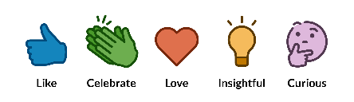

* Professional and consumer **social *interactions*** – these are things like “I use this product,” “I have a question,” “I am interested in this offering,” and similar Medigy CADDs. Social interactions are a little more meaningful as peer reviews because they indicate a little more forethought and consideration. When tied to the type of user (e.g. patient, doctor, etc.) even simple social interactions can have significant value.
* Professional and consumer ***qualitative experiences*** – these are CADDs like pros/cons, integrates with, similar to, confirmed devices, etc. These qualitative experiences provide significant context and awareness of the functionality of an offering, more than simple social reactions and social interactions, but less than quantitative evaluations. With proper qualitative experiences tracked by user type (e.g. nurse, doctor, patient, etc.) we can get some great insights without a lot of quantitative work.
* Professional and consumer ***quantitative evaluation***s – these are LHC Forms (LForms) that provide the most meaningful insights. When combined with type of user and ability to do detailed structured comparisons quantitative evaluations provide the highest peer review value but are the most difficult to get filled out.

# Content Addressable Dimensional Data (CADD)

Social reactions, social interactions, and qualitative experiences are implemented using CADDs. CADDs are prometheus metrics for any piece of content in the system or external permalink. Every piece of content can have unlimited CADDs attached and they can be tied to user type, user name, and a variety of other dimensions so that they’re easy to publish in a variety of formats.

# CADDs for Offerings (Products, Services, Solutions, etc.)

On the offering page, we want people to get an immediate summary and see what their peers think about the offerings.

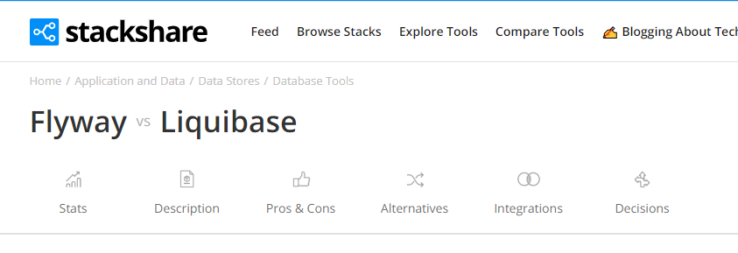

* Who else is using the software, broken out by institution type or user type (patient, doctor, admin staff, etc.). We can use pre-defined taxonomies for institution types and professional roles (see taxonomy documents). [ [OP #2063](https://openproject.netspective.com/projects/www-medigy-com/work_packages/2063/activity) ]
  + {Used by #Count} [We use <offering> #Count] {Pros #Count} {Cons #Count} [Share Pros & Cons]
  + e.g. 
* Add a new true/false icon for CMS’s [Data at the Point of Care](https://dpc.cms.gov) ([https://dpc.cms.gov](https://dpc.cms.gov/)). This is basically a new brand for the BlueButton 2.0 standard. [ [OP #2116](https://openproject.netspective.com/projects/www-medigy-com/work_packages/2116/activity) ]
* Add a new Net Promoter Score (NPS) icon showing the average rating by asking a [single question NPS survey](https://www.retently.com/blog/nps-survey-templates/) – this would basically replace customer satisfaction survey that is [asked by KLAS and similar companies](https://www.beckershospitalreview.com/ehrs/klas-more-than-half-of-cerner-clients-dissatisfied-with-implementation-it-advisory-services.html). This would be implemented using medigy_qual_exp_nps but we’ll want to figure out how to ensure that they’re using it. So, only allow NPS survey to be answered by those who also answer that they’re using the offering. [ [OP #2231](https://openproject.netspective.com/projects/www-medigy-com/work_packages/2231/activity) ]
* Add a new section/tab called “Pros & Cons” that others can vote on – ask “What do you like about <offering>?” and “What do you not like about <offering>?” [ [OP #206](https://openproject.netspective.com/projects/www-medigy-com/work_packages/2064/activity)4 ]
  + - 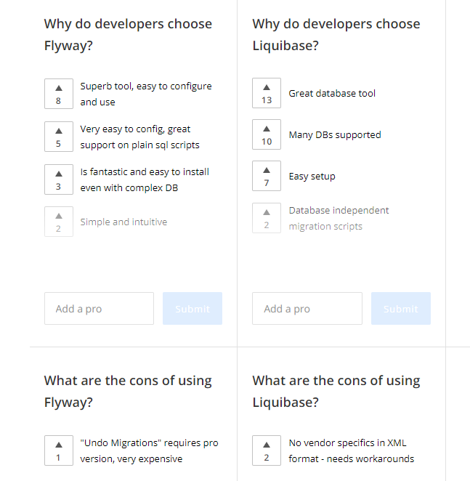
    - Each pro/con can just become metrics and easily tracked in Prometheus
* Who else is interested in using the offering, broken out by user type. [ [OP #2049](https://openproject.netspective.com/projects/www-medigy-com/work_packages/2049/activity) ]
  + Medigy Star indicates simple interest if this is not an open source solution (OSS) – this could just replace our current “upvote” so an “upvote” is now a Medigy Star
  + GitHub Star if it’s an OSS, in addition to Medigy Star?
  + “Watch” or “Subscribe” indicates higher interest
  + 
* How many have added this to their wishlist (like a shopping cart) or have already made decisions to use the offering. This is kind of like a free-form “Comments” section but more focused on decision-making and not general discussion. [ [OP #2050](https://openproject.netspective.com/projects/www-medigy-com/work_packages/2050/activity) ]
  + {On Wishlists #Count} [Add to Wishlist]   
    {Decisions Made #Count}   
    {Alternatives Seen #Count} {Alternatives Tried #Count} [Add Alternatives] {Alternative For #Count} [Add as Alternative]
  + 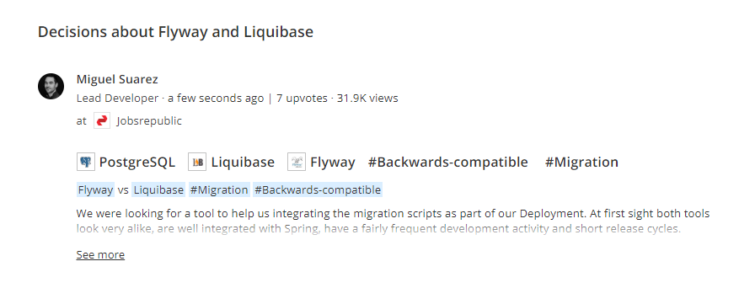
  + 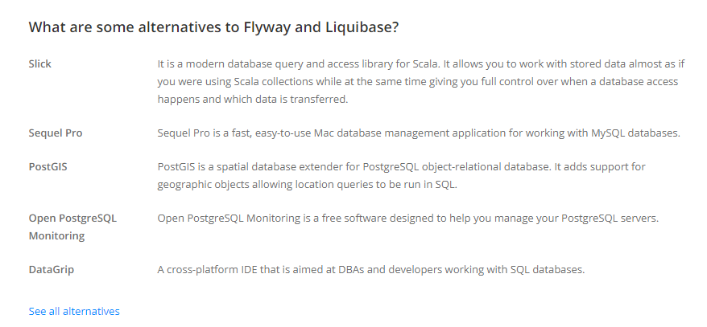
* How many have asked questions about the solution on our site [ [OP #2054](https://openproject.netspective.com/projects/www-medigy-com/work_packages/2054/activity) ]
  + {Questions Asked #Count} [Ask a Question]
  + 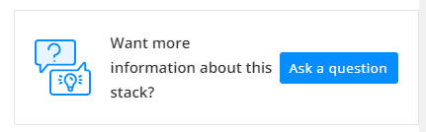
* How many external references are available? [ [OP #2055](https://openproject.netspective.com/projects/www-medigy-com/work_packages/2055/activity) ]
  + Twitter
  + Facebook
  + Google PageRank
  + Bing ranking
  + Alexa ranking
  + TechCrunch funding, ranking, etc.
  + Quora
  + TrendMD
  + Outbrain
  + Etc.
* How many integrations with other products are proven [ [OP #2058](https://openproject.netspective.com/projects/www-medigy-com/work_packages/2058/activity) ]
  + {Integrated With #Count| [We’ve integrated this]
  + 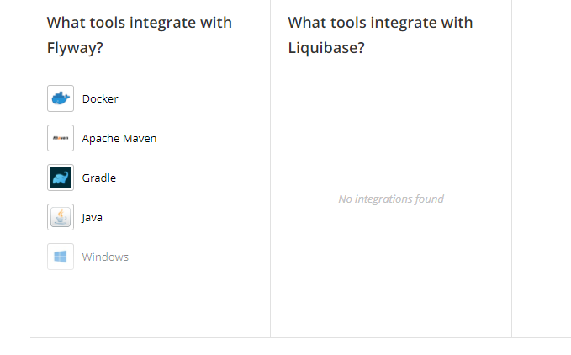
* How many confirmed capabilities or what functionality has been voted on? [ [OP #2060](https://openproject.netspective.com/projects/www-medigy-com/work_packages/2060/activity) ]
  + {Functionality #Count]} [Confirm Functionality]
  + Allow offerers to report a feature and then allow other users to confirm (vote) on whether the capabilities or features present
  + Similar to pros/cons – tracked through Prometheus
  + 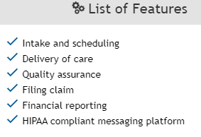 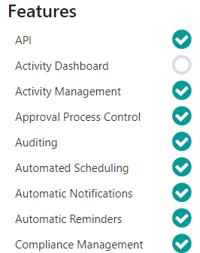
* How many confirmed devices does the offering work on? [ [OP #2061](https://openproject.netspective.com/projects/www-medigy-com/work_packages/2061/activity) ]
  + {Devices Supported #Count} [Confirm Device]
  + Allow offerers to report devices and then allow others to confirm (vote) on whether they agree with the Device support
  + 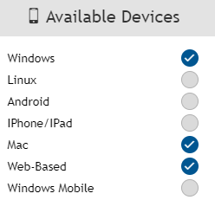
* What other app stores is the offering found in and what are the ratings [ [OP #2062](https://openproject.netspective.com/projects/www-medigy-com/work_packages/2062/activity) ]
  + Product Hunt URL and rating
  + Google Play store URL and rating
  + iOS App Store URL and rating
  + Epic app store and rating
  + Cerner app store and rating
  + Allscripts app store and rating
  + G2 Crowd, and other rating sites
* Podcast links, video links, content URLs, blog posts, etc. for mentions [ [OP #2087](https://openproject.netspective.com/projects/www-medigy-com/work_packages/2084/activity) ]
* Screenshots, documents, and other files can be uploaded into GitLab-linked repo for each offering. We can use a simple Git manager, Box, OneDrive, or Minio to let offerings’ managers maintain their files
* Funding and Capital Raised from press releases, TechCrunch, and other databases / news articles (see attachment for Fard’s email as an example) [ [OP #2117](https://openproject.netspective.com/projects/www-medigy-com/work_packages/2117/activity) ]
  + 
* “See Also” style references pointing to Pubmed and other articles similar to the description provided – from [NIH MeSH](https://meshb.nlm.nih.gov/MeSHonDemand), TrendMD, etc. [ [OP #2118](https://openproject.netspective.com/projects/www-medigy-com/work_packages/2118/activity) ]
* “Real World Evidence” (RWE) capture – asking simple questions of the type of RWD/RWE the offering captures (medium priority, not high). [ [OP #2131](https://openproject.netspective.com/projects/www-medigy-com/work_packages/2131/activity) ]

## “Earn Cash for Evaluating”

Ask the question like “Want to get paid for evaluating <offering name>?” near the “Quantitative Evaluation” subject heading in the offering home page. [ [OP #2132](https://openproject.netspective.com/projects/www-medigy-com/work_packages/2132/activity) ]Institution Home Page Strategy [ [OP #2068](https://openproject.netspective.com/projects/www-medigy-com/work_packages/2068/activity) ]

* They can say that they want to be anonymous for reports (still identified by their user type taxonomy)
* Vendors will be able to evaluate and rate hospitals for the ease with which they can do business with Hospitals
* As hospital users end up using the qualitative experiences for things like “Used by” then the reports will be reversed and users can see which offerings they are using
* Hospitals and health systems will be able to show their challenges and problems as RFCs (Request for Comments) and RFIs (Request for Information)

# Community and Topic Homepage and CADDs [[OP #2090](https://openproject.netspective.com/projects/www-medigy-com/work_packages/2090/activity)]

Add a new section at the top to say “Know anyone building innovative solutions for *<topic or community>*? Invite them to submit their offerings >>”. We’ll then send an email with a special landing page (similar to a claim landing page) which allows a user to sign up and put things directly into the category.

Every topic has a home page, called the Topic Home Page; there are special topics called “Communities”.

* It will allow people to view all entries in that category
* Provide an explanation of what the category is
* Add offerings to the category
* Allow managers to manage the category
* Allow people to subscribe (watch) the Community for any new entries, etc.
* We may also allow challenges, OKRs, etc. to be assigned to the category to see which products meet the OKRs.
* We can allow group members or owners to add links to resources that might be useful – have Dhanya think about rareLife type groups (“guided communications”) and prepare list of good capabilities that would drive traffic or utilization
* “Earn Cash for Managing this Community” – ask question like “Want to get paid for managing <<community name>>?”

A good example might be to use the [KLAS Research Population Health IT Report](https://klasresearch.com/report/keystone-summit-2016/1237) and how they’ve presented the topic with good content. Talk with Shahid about how to work this into Medigy.

Read [*How to Create an Online Community That People Will Pay For*](https://hbr.org/2019/09/how-to-create-an-online-community-that-people-will-pay-for) to learn more about how to make our category-community pages more useful.

Another section we need to have in the Community is to tie in the influencers who specialize in the community (basically each influencer can be tied to one or more categories)

## Community Section Theme

Topics home pages and associated content are auto-generated but Community sections are manually created and need to be flexible. See the following themes as examples for how a Community section should look:

* <https://github.com/sethmacleod/hugo-magazine>

### Each Community is a Git Repo

The Opsfolio Cybersecurity Community, the Opinion section (migration from HealthcareGuys.com), and any other “manually created Community” section should look like a magazine section and have its own Community repository in Git with separate markdown.

# Individuals and Influencers Home Page and CADDs [[OP #2234](https://openproject.netspective.com/projects/www-medigy-com/work_packages/2234/activity)]

Need to create a medigy.com/influencers which will pull data from institutional, individual, advocacy, regulatory, and other influencers. We can list them in our identity software but we can allow many CADDs for social reactions, social interaction, and qualitative experience with influencers. For institutions and consultants we might even allow quantitative evaluations using LHC Forms.

* **Clinical Institutions**. The top clinical institutions like Mayo Clinic, Cleveland Clinic, and others that have their own thought leaders and “followings” – could also include large academic medical centers with significant NIH funding dollars … all grants are public and should be able to find them here.
* **Analyst Institutions**. KLAS, Frost & Sullivan, Gartner, Forrester, IDG, and other analysts.
* **Individual Professional Analysts**. Anyone that doesn’t work for a institution but is doing professional analyst work.
* **Individual Thought Leader**. Folks like Shahid, Brian Ahier, John Lynn, Rasu Shrestra, etc. Need to find posts like [Healthcare Technology Influencers lists](https://healthtechmagazine.net/article/2019/09/2019-healthcare-technology-influencers-list-healthtechs-30-must-follow-health-it-influencers) and [19 top health tech influencers to follow](https://www.scality.com/solved/20-top-health-tech-influencers-to-follow/?utm_campaign=coschedule&utm_source=twitter&utm_medium=scality&utm_content=19%20top%20health%20tech%20influencers%20to%20follow) There are many such Twitter lists and others, we’ll put them on there.
* **Regulatory Bodies**. FDA, CMS, ONC, etc. in the USA and others across the world.

*For further requirements research: it’s worth reading TechCrunch’s* [*Venture capitalists ‘like and subscribe’ to influencers*](https://techcrunch.com/2019/11/04/venture-capitalists-like-and-subscribe-to-influencers/) *– it describes, in details, a lot of ideas that we must incorporate into our influencer sections.*

Any influencers that have affinity to specific categories (e.g. KLAS) should show up in their Community pages, too.

Once we have even a small number of influencers properly cataloged then we can create posts like ***What’s Keeping Medical Practices Up At Night?*** and [***What’s Keeping Hospitals and Health System CIOs Up At Night?***](https://www.healthcareittoday.com/2019/09/27/whats-keeping-hospitals-and-health-system-cios-up-at-night/) Which are great examples of how influencers can give excellent input in a structured way.

Many influencers are job seekers and many job seekers might be influencers too. Take a look at the [dribbble.com](https://dribbble.com/) home page for inspiration and ideas.

For influencers, look at deepbench.io and similar project solicitation sites to allow freelancing for influencers and hire them directly for jobs on Medigy.com. Deepbench.io and similar sites should be researched to see how they can be used to generate research or other projects.

See attached CG Consults GovCon EoD Overview.pdf (also tracked in [Lectio #223](https://op.infra.lectio.cc/projects/lectio/work_packages/223/activity)). We’ll want to create a Medigy EoD strategy so that influencers make money off Medigy.



# Lectio-like Medigy extension for submissions and alerts [[OP #2091](https://openproject.netspective.com/projects/www-medigy-com/work_packages/2091/activity)]

Let’s think about how to improve offering submissions so that we can make it easier. Perhaps using a Lectio-like extension that can ask the questions in an extension and do auto-analysis of rating sites, etc. to pull data makes sense? Meaning go onto a product website and then press the Medigy extension to auto-parse the contents and anything else we can find across website and then submit the offering on behalf of the user?

# Top-level Q&A similar to Roadmap.com and StackOverflow, etc. [[OP #2458](https://openproject.netspective.com/projects/www-medigy-com/work_packages/2458/activity)]

Medigy.com/question will be a Q&A (like roadmap.com and stackoverflow.com) which will collect questions at the category level, offering level, and present it in a unified time-based view.

# CB Insights Market Maps as new category source, categories, and offerings (communities) [[OP #2235](https://openproject.netspective.com/projects/www-medigy-com/work_packages/2235/activity)]

See the CB Insights [Market Maps](https://www.cbinsights.com/research/market-map/) page and articles like [The Digital Hospital: 100+ Companies Reinventing Medicine In One Infographic](https://www.cbinsights.com/research/digital-hospital-market-map-expert-research/). CB Insights would be similar to KLAS and get its own category source. Then, each Market Map like these can be used to find offerings and curate them into the appropriate category – we’ll want to brand CB Insights so that we can get inbound leads.

See these to start, and find others like:

* [Digital Health Insights](https://www.cbinsights.com/research/digital-health/) (CB Insights’ Health Team)
* [The Digital Hospital: 100+ Companies Reinventing Medicine In One Infographic](https://www.cbinsights.com/research/digital-hospital-market-map-expert-research/)
* [The 20+ Healthcare Startups In GE Ventures’ Portfolio](https://www.cbinsights.com/research/ge-venture-healthcare-portfolio-market-map/)
* [The Body Series: How Technology Is Reimagining Brain Research & Disease Treatment](https://www.cbinsights.com/research/body-series-brain-tech-startups/)
* [40+ Companies Using Tech to Get Drugs To Patients More Quickly, Cheaply, & Safely](https://www.cbinsights.com/research/drug-pharmaceutical-supply-chain-market-map-expert-intelligence/)
* [40+ Companies Leveraging the Microbiome To Change The Way We Manage Our Health](https://www.cbinsights.com/research/microbiome-health-startups-market-map-expert-intelligence/)
* [Fitness Tech Market Map: 75+ Companies Enhancing Your Workout Routine](https://www.cbinsights.com/research/fitness-tech-market-map-expert-research/)
* [120+ Companies Shaping the Future Of Self-Care](https://www.cbinsights.com/research/beauty-grooming-market-map-expert-intelligence/)
* [Present & Centered: 65+ Mindfulness Companies in One Market Map](https://www.cbinsights.com/research/mindfulness-market-map-expert-intelligence/)
* [55+ Startups Using Tech to Transform How We Sleep](https://www.cbinsights.com/research/sleep-tech-market-map-expert-intelligence/)
* [150+ Startups Cultivating the Wellness Industry](https://www.cbinsights.com/research/wellness-tech-startups-market-map/)

# External badges for inbound links (improves SEO) [[OP #2092](https://openproject.netspective.com/projects/www-medigy-com/work_packages/2092/activity)]

Create badges like product hunt:

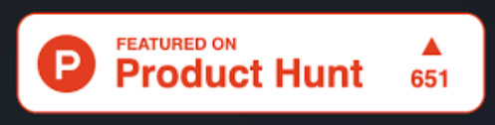

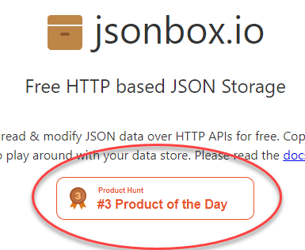

# PostgreSQL Distributed Data Computing Platform (Pg**DCP**) – “Zero Middleware” for Structured Content

## PgDCP schema objects migration and management strategy

Use Liquibase Database as Code (“DaC”) for all DDL, DQL, DML, etc. when possible. When not possible, tell Shahid first.

## PgDCP Extract, Transform, and Load strategy (ETL) strategy

* Keep batch or staged ETL to a minimum and use PostgreSQL Foreign Data Wrappers (FDWs) and PostgreSQL schema objects like views and materialized views to shape data.
* When external sources cannot be retrieved as an FDW, use Singer.io ETL ‘taps’ specification for pulling data into PgDCP ‘target’. We can use singer.io specs or Transferwise’s Pipelinewise framework. But, any ETL tools that support PostgreSQL and PgDCP should be evaluated.

## PgDCP identity and row-level data access management strategy

If identity-based row level data security is important, [see these instructions](https://aws.amazon.com/blogs/database/managing-postgresql-users-and-roles/). Use Keycloak for identity and then use PostgreSQL users/passwords and PostgreSQL row-level security that’s best because security is tied to the data.

## PgDCP design strategy

PgDCP is built on top of existing PostgreSQL schemas like OpenProject, SuiteCRM, OpenClinica, and TT RSS or it can be a custom schema built by us on our own (e.g. FixedOps.CC). In any case, the ideal situation is to use PostgreSQL in a “Zero Middleware” approach so that we never require any service layer outside of Hasura (see below).

In the example below, we’ve expanded on what a PostgreSQL structure might look like – the purple boxes are the “internal” schema objects (accessible for private use). All the green boxes describe how external APIs and access should occur – basically, only static views, materialized views, and “ETL” views (views wrapping other views or tables for shaping and reshaping data) should be externally available.

By properly creating layered views, almost any kind of data shaping can occur on top of application tables, custom tables, FDWs, stored functions, and stored procedures. If building on top of another application (e.g. OpenProject, OpenClinica, etc.) engineers can make calls to OpenProject APIs as PL/Python or PL/v8 and wrap in views that will become Hasura schema. This allows further external protection and gives engineers polyglot language choices.

## PgDCP GraphQL API and external access strategy

Use SQL internally but externally use Hasura (preferred) and [PostgREST](http://postgrest.org/en/v6.0/) (allowed, but not preferred) which auto-generates GraphQL schema (preferred) and REST APIs (allowed, but not preferred) based on PostgreSQL objects. If PostgreSQL schema objects are named and related properly, almost the entire GraphQL Schema or REST API could be easily auto generated. Reminder, if identity-based row level data security is important, [see these instructions](https://aws.amazon.com/blogs/database/managing-postgresql-users-and-roles/).

# Markdown Pipelines Infrastructure for Unstructured Content

An ideal way of preparing complex HTML publishing is to use Static Site Generators (SSGs) like Hugo (our preferred tool). Most SSGs use Markdown sources and directory conventions to generate HTML from Markdown.

Each major pipeline will be a container and running the container will generate either a static file system or Git repository with final markdown files – then, the final Publisher container service will just combine all the file systems and run Hugo one time. Each Markdown Pipeline container can run independently and with any frequency.

# Medigy Daily Brief Home Page Design

**Daily Brief** (Today) is the unified “what’s new” page and may become the new start page at some point. This section will grow over time to pull across all other content from content aggregation pipelines across the system and the many different sections we’re creating. It might also be a unified front end to non-Medigy content too.

Start with the design below.

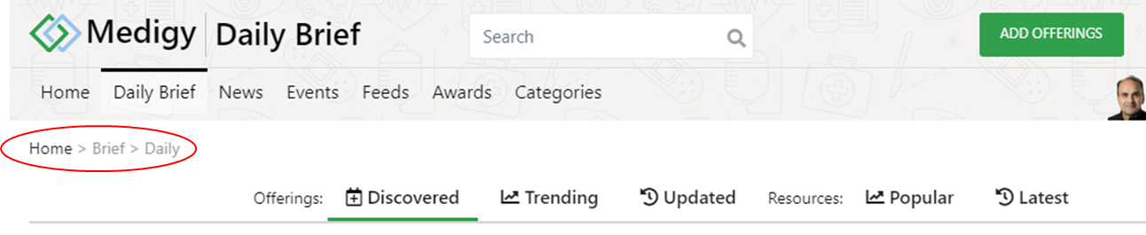

## Daily Brief Submenu Items

* Discovered Offerings (medigy.com/brief/daily/offerings/discovered)
  + List of offerings by most recent submission date, listed items point to medigy.com/offering/* home pages
* Trending Offerings (medigy.com/brief/daily/offerings/trending)
  + List of what’s trending, listed items point to medigy.com/offering/* home pages
* Updated Offerings (medigy.com/brief/daily/offerings/updated)
  + List of offerings by most recent updated date, listed items point to medigy.com/offering/* home pages
* Resources: Popular/Recent
  + Combined News, Feeds, Events, Research, etc. being curated from all the other parts of Medigy … links to their respective primary sections
  + <https://Medigy.com/brief/daily/resources/popular>
  + <https://Medigy.com/brief/daily/resources/latest>

# Innovation Coach Home Page Design [OP #1100]

Shahid will prepare a “[DIFFUSION OF INNOVATION](https://www.healthaffairs.org/topic/bms050)” Community.

Like this:

* https://www.healthaffairs.org/do/10.1377/hblog20170516.060078/full/
* https://petersonhealthcare.org/diffusion-innovation

See “A systematic review of implementation frameworks of innovations in healthcare.pdf” to create frameworks for the “Medigy Innovation Council”.

# Knowledge taxonomies, equivalence, similarities, representation, and governance

Medigy will offer a complex, sophisticated, mapping of multiple taxonomies with equivalence and similarity management and OWL-based representation through Protégé or other taxonomy services. All of our content, including offerings, news, events, feeds, and dozens of other content types will all be based on a unified taxonomy.

We will support as many different classifications and taxonomies as necessary to represent our content. Medigy’s “bridge” taxonomy will be based on the NIH Medical Subject Headings (MeSH) structure. MeSH is an imperfect taxonomy but it’s primarily a “bridge” between the various taxonomies, knowledge representation, and topic classification systems out there. MeSH is imperfect because it focused on biological vocabulary (though it does have certain things we care about like Patient participation 🡨🡪 Patient engagement). When MeSH has something that matches what we need in Medigy, we’ll use it. When MeSH does not have something that we need in Medigy then we’ll use other taxonomies and create OWL links between them.

The most important thing to recognize is that we’ll support many, dozens perhaps hundreds, of topic classification and knowledge representation taxonomies and as we add a taxonomy we’ll need to connect them to our other taxonomies through one or more “bridges”. MeSH is the “primary bridge” but is not the only one.

See below for a visual representation of how this might work.

## Taxonomy for Medical Subject Headings (MeSH)

<https://www.nlm.nih.gov/mesh/meshhome.html>

<https://learn.nlm.nih.gov/documentation/training-packets/T000101112/>

Specifically check out [MeSH on Demand](https://learn.nlm.nih.gov/documentation/training-packets/T000101112/) ([see demo](https://meshb.nlm.nih.gov/MeSHonDemand)) for an API to automatically find terms – this might be our best solution.

## Taxonomy for Medical Device Offerings

<https://www.fda.gov/media/94057/download>

<https://www.emergobyul.com/services/europe/european-medical-device-classification>

## Taxonomy from third-party recommendation platforms

See [TrendMD](https://www.trendmd.com/how-it-works-publishers), SmartBrief, Outbrain, etc.

## Taxonomy for Medical Research Outcomes

<https://www.sciencedirect.com/science/article/pii/S0895435617305899>



## A Taxonomy of Definitions for the Health Data Ecosystem

<https://fpf.org/wp-content/uploads/2019/05/A_Taxonomy_of_Definitions_for_the_Health_Data_Ecosystsm_5.29.19_accessible.pdf>



## Enhancing our Marketplace through proper audience selection

|  |  |  |  |  |
| --- | --- | --- | --- | --- |
| Used by | Purchased by | Benefits |  |  |
| Credentialed Healthcare Delivery Professionals (HDP) | Healthcare Delivery Organization (hospital, health system, physician practice, etc.) |  |  |  |
| Licensed HDPs | Professional |  |  |  |
| Unlicensed HDPs | Patient |  |  |  |
| Patients | Professional patient advocate |  |  |  |
| Volunteer Patient family or caretakers | Volunteer patient advocate or caretaker |  |  |  |
| Professional patient advocate |  |  |  |  |



### Used by

[Health Care Provider Taxonomy Code Set • ASC X12 External Code Source 682](http://www.wpc-edi.com/reference/codelists/healthcare/health-care-provider-taxonomy-code-set/)

### Purchased by

[Health Care Provider Taxonomy Code Set • ASC X12 External Code Source 682](http://www.wpc-edi.com/reference/codelists/healthcare/health-care-provider-taxonomy-code-set/)

### Benefits

?

## [Unblock Health] Enhancing our Marketplace by identifying the kind of data an offering collects, manages, etc.

[The Integrated Taxonomy of Health Care: Classifying Both Complementary and Biomedical Practices Using a Uniform Classification Protocol](https://www.ncbi.nlm.nih.gov/pmc/articles/PMC3091472/)

[A taxonomy of health data](https://susannahfox.com/2019/02/04/a-taxonomy-of-health-data/)

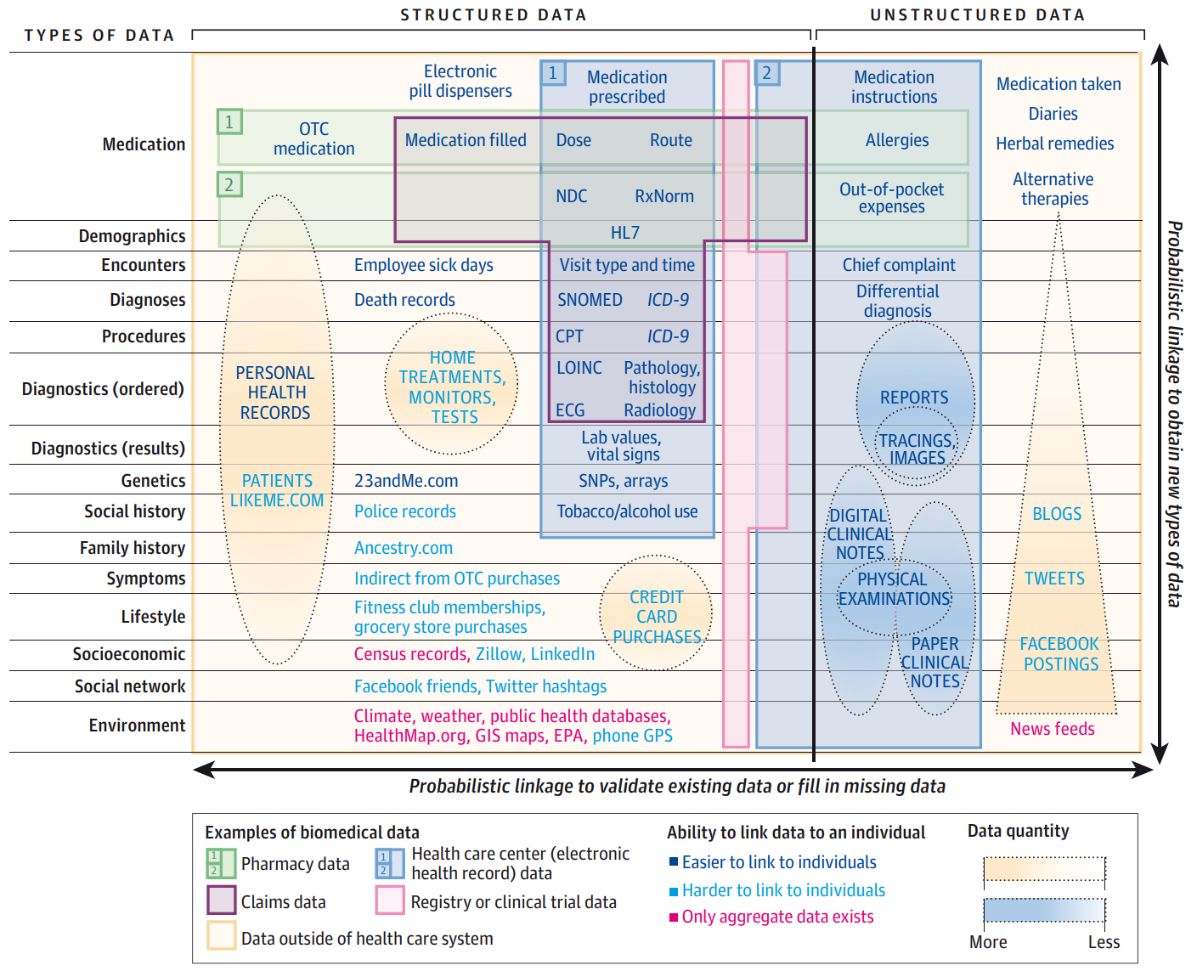



## [Unblock Health] Patient complaints about hospital services: applying a complaint taxonomy to analyse and respond to complaints

<https://academic.oup.com/intqhc/article/28/2/240/1750449>



## A TAXONOMY OF INNOVATION: CONFIGURATIONS OF ATTRIBUTES IN HEALTHCARE INNOVATIONS

<https://www.researchgate.net/publication/227652011_A_taxonomy_of_innovation_Configurations_of_attributes_in_healthcare_innovations>

## A Taxonomy of Pervasive Healthcare Systems

<http://citeseerx.ist.psu.edu/viewdoc/download?doi=10.1.1.526.5688&rep=rep1&type=pdf>

## A Taxonomy of Telemedicine Efforts with respect to Applications, Infrastructure, Delivery Tools, Type of Setting and Purpose (2005)

<http://users.wpi.edu/~bengisu/files/tulu_etal_HICSS2005.pdf>

## A Taxonomy of Integration Interventions Between Health Care and Public Health

<https://pdfs.semanticscholar.org/dc30/918b08f457f5591f7a52df16da7da0924265.pdf>